**THE HANGMAN GAME**

I will start with HTML file. There is two canvas. One canvas for hanging man other canvas for putting the letter that guessing letter. There are four buttons. First button group for letters, a second button for starting a game, a third button for checking a word guess and last one for play again. There is five audio. First audio for the right answer, second audio for the wrong answer, third audio for the wrong letter, fourth audio for right letter and last one for the used letter. There is one textbox for guess the word. There is one option for choose category. There is five paragraph. The first paragraph for a category name, second paragraph for remaining lives, third paragraph for the used letter, fourth paragraph for information that “use ‘-‘ instead of space character”, and last one for a score. There is two image for a wrong answer and right answer. There is a footer to know who made this game.

In the javascript file, there is four array. First one for creating letters button and the others for words. I use an event listener for checking button click state. I use one more event listener for checking keyboard inputs. There are eight functions for drawing a hangman. There is a function (makeCat) for fill option tag. There is a function (playGame) for the start a game. There is a function (check) for checking clicked the letter is in the word. There is a function for creating letters button. There is a function (trying) for checking guess word is equal to the word. There is a function (makeBoxes) for a draw box for each letter of the word. I use animation for the wrong answer and the right answer. There are audio files. If click or pass the wrong letter, the wrongLetter.mp3 file is playing. If click or pass the right letter, the rightLetter.mp3 file is playing. If click or pass the used letter, the usedLetter.mp3 file is playing. If you find an answer, the goodJob.mp3 file is playing. If the game over, gameOver.mp3 file is playing. If you find an answer, an alert comes. If the game over, an alert comes.

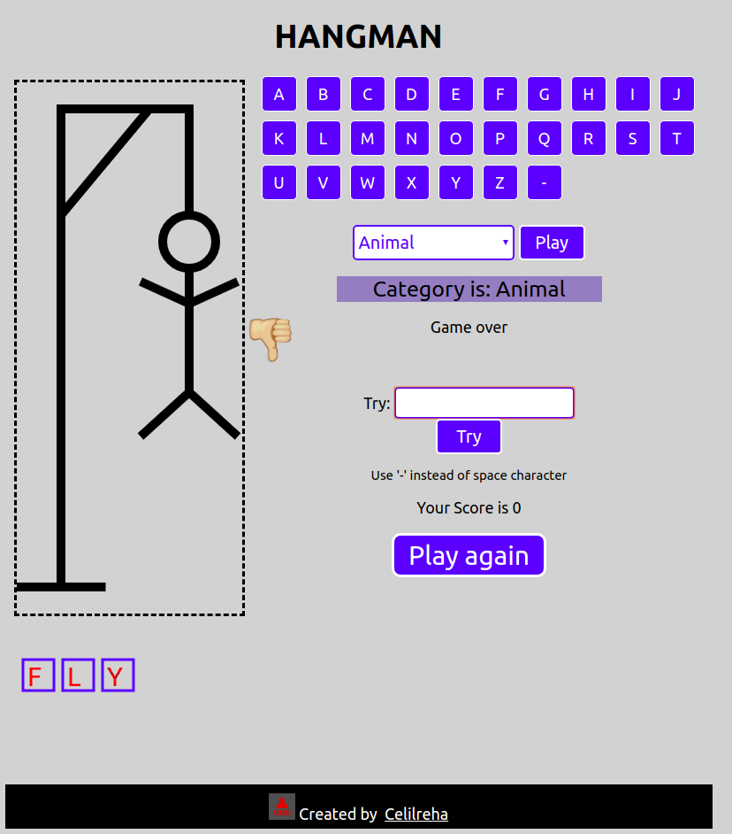

Celil Reha ESGICE